**CPE223 – Signals and Systems**



**Lab # 2**

**To Describe the Periodic and Aperiodic Continuous and Discrete Time Signals Using Elementary Signals in MATLAB.**

|  |  |
| --- | --- |
| **Name** | Muhammad Aizaz Arshad. |
| **Registration Number** | 088. |
| **Class** | FA18-BCE-A. |
| **Instructor’s Name** | Sir Umair Shafique. |

**Assessment**

|  |  |  |  |
| --- | --- | --- | --- |
| **Performance** |  |  | **Total** |
| **Results** |  |  |
| **Lab Report** |  |
| **Viva** |  |

**OBJECTIVES:**

Describe and show the basic Continuous and Discrete time signals (sinusoidal and complex exponential) by using unit step and unit impulse signals.

**REQUIRED EQUIPMENT:**

**Software:**

* **MATLAB**

**METHODOLOGY:**

Firstly, this lab introduced the periodicity of the signals. A periodic function is a function repeating itself after regular intervals of time. Time period of a function can be calculated as: (T = 2π/ω).

Secondly, unit step functions were being taught (The Function is basically not defined at t=0. The MATLAB command which generates it is Heaviside (t). Heaviside is not a function. Plotted discrete and continuous time signals simultaneously using stem and plot respectively. Plotted digital signals (Same as CT signals but instead of t n is used which is the no.of sample. All types are same and are known as sequences. Use stem command to plot trigonometric functions. Plotted signals for more than 1 time periods. Plotted exponential functions, by using (exp) command. Used Heaviside function. Used Dirac function. Using these signals the student will be able to distinguish between periodic and aperiodic signals.

**LAB TASK:**

t = -88:0.1:88

f = cos(t)

plot (t,f)

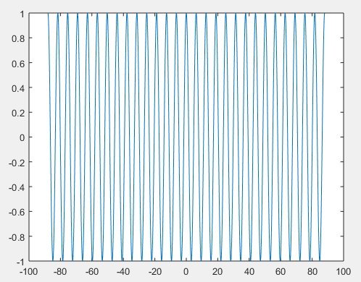

Task 2:

t = -88:0.1:88

y = cos(t)

stem(t, y)

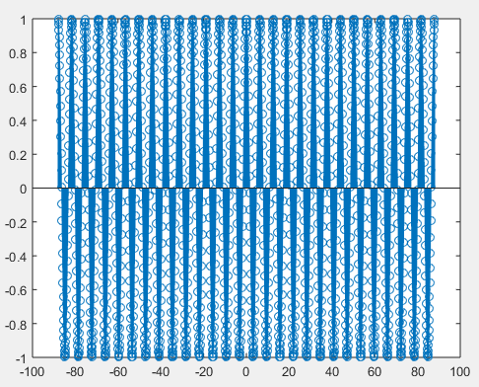

Task 3:

t = -88:88;

n = -88:88;

f = cos(t);

hold on;

subplot(2,1,1)

plot(t, f)

subplot(2,1,2)

stem(n, f)

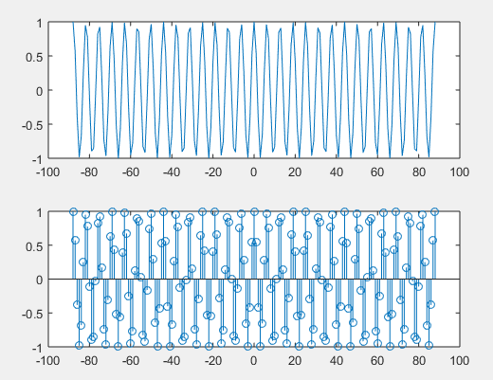

Task 4:

t = -88:0.1:88;

f = cos(t);

round (n)

round(f)

stem(t, f)

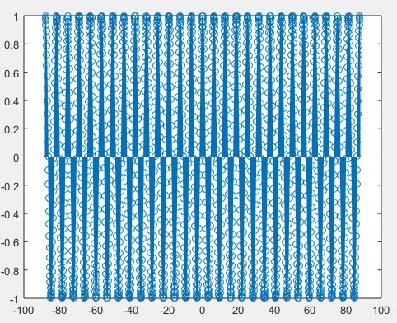

Task 5:

t = -4:5;

f = 3 * cos(3 *pi *t +pi/3);

plot(t, f);

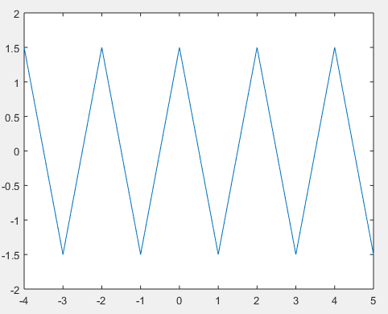

Task 6:

t = -5:0.1:5;

x1 = cos(t);

x2 = sin(t + pi/2);

subplot(2,1,1);

plot(t, x1)

subplot(2,1,2);

plot(t, x2)

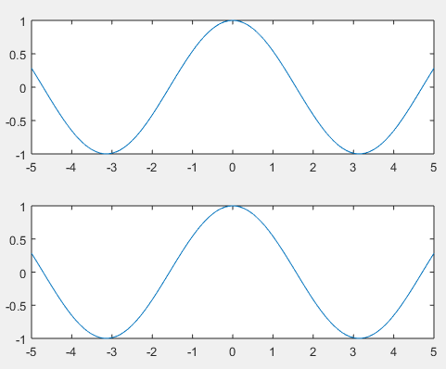

**CONCLUSION:**

In this lab we were able to get a grip on continuous and discrete time signals. We were able to differentiate between different continuous time signals like Sinusoidal, Complex exponential, Exponential signals, Unit step function etc. and different discrete time signals like Unit impulse sequence, Unit impulse sequence, Unit step sequence etc. We have also learned about plotting the continuous time and discrete time signals together in the same task.